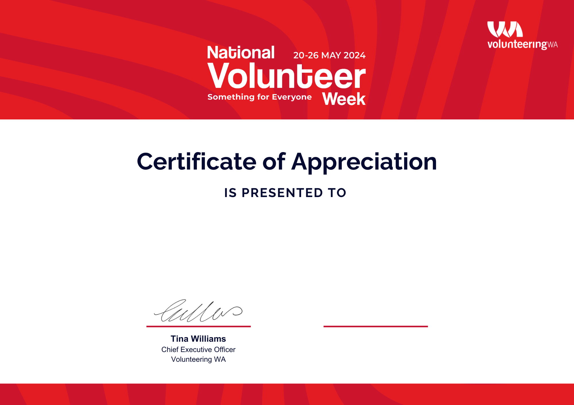

**Your CEO**

Chief Executive Officer

Your Organisation

**Thank you for dedicating your time to help the community**

**Full Name**

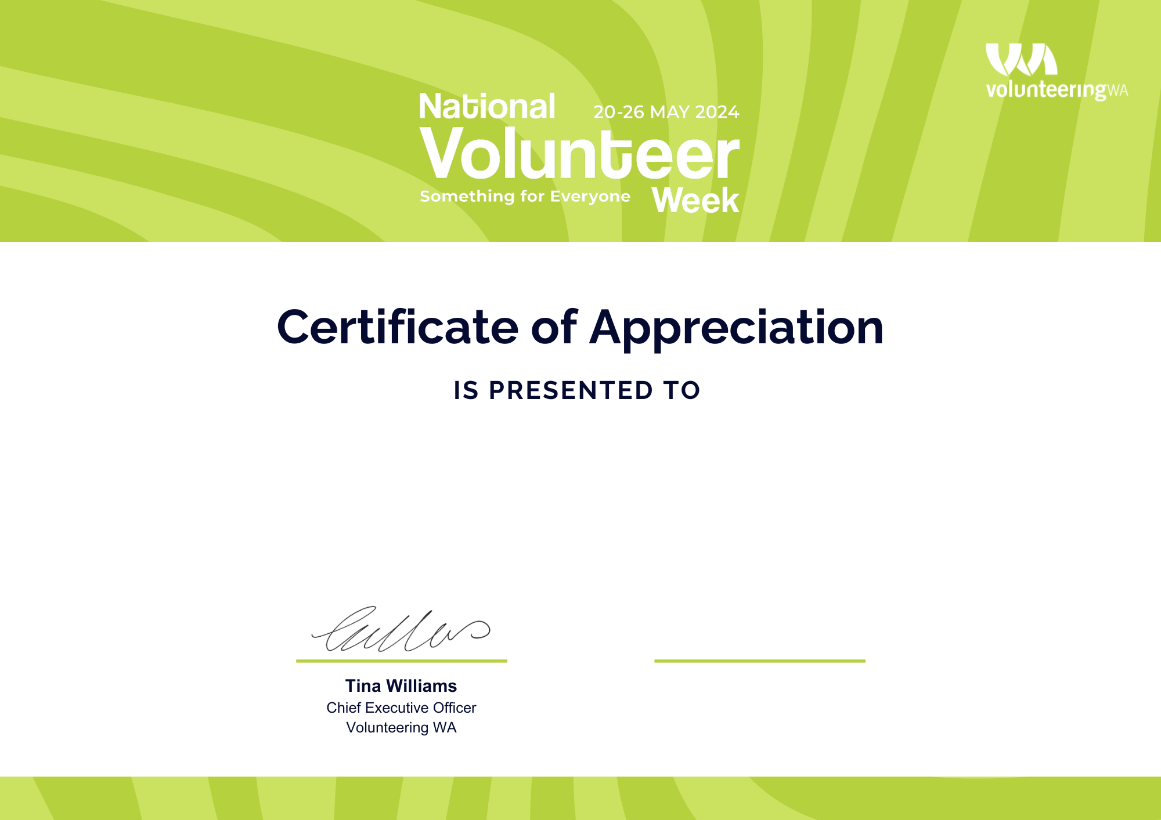

**Your CEO**

Chief Executive Officer

Your Organisation

**Thank you for dedicating your time to help the community**

**Full Name**

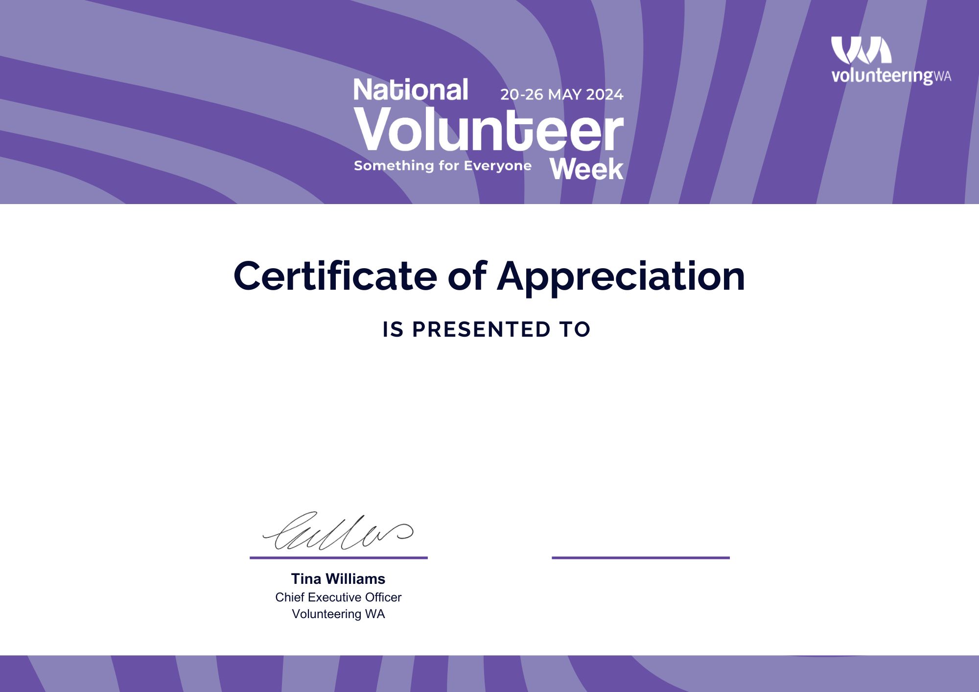

**Your CEO**

Chief Executive Officer

Your Organisation

**Thank you for dedicating your time to help the community**

**Full Name**

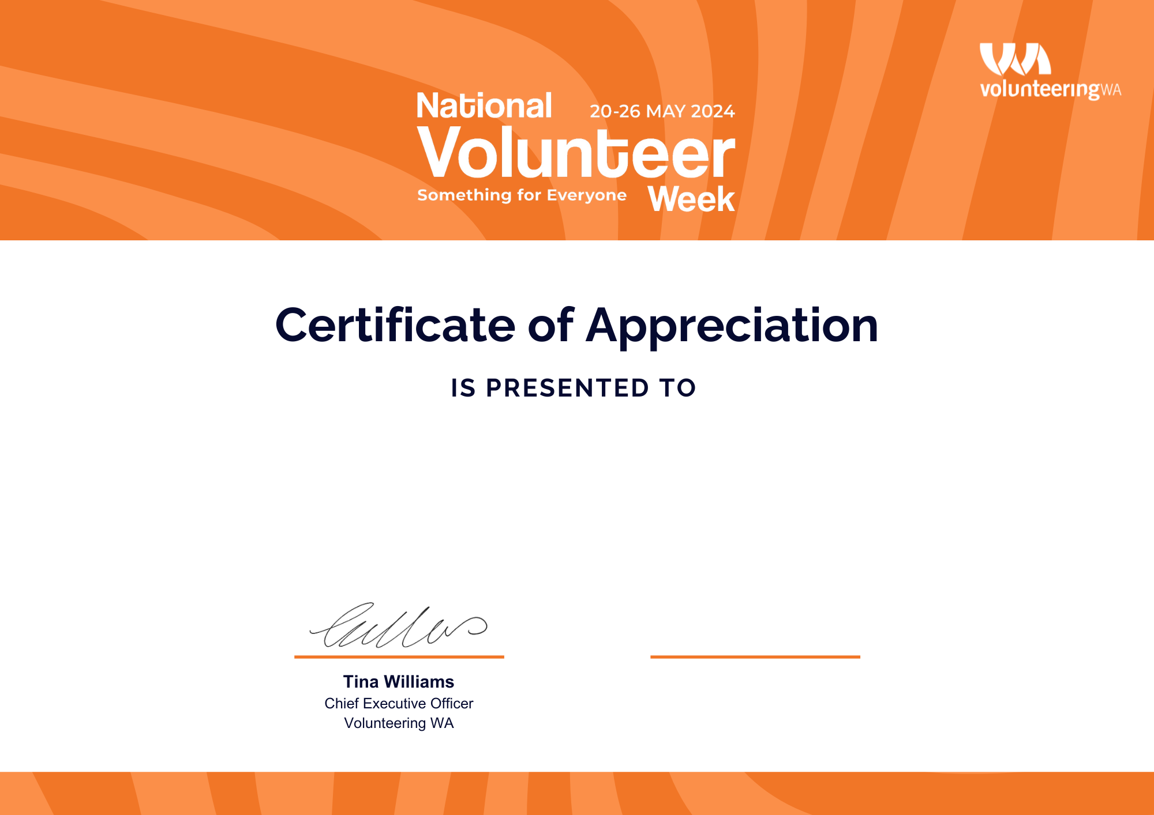

**Your CEO**

Chief Executive Officer

Your Organisation

**Thank you for dedicating your time to help the community**

**Full Name**

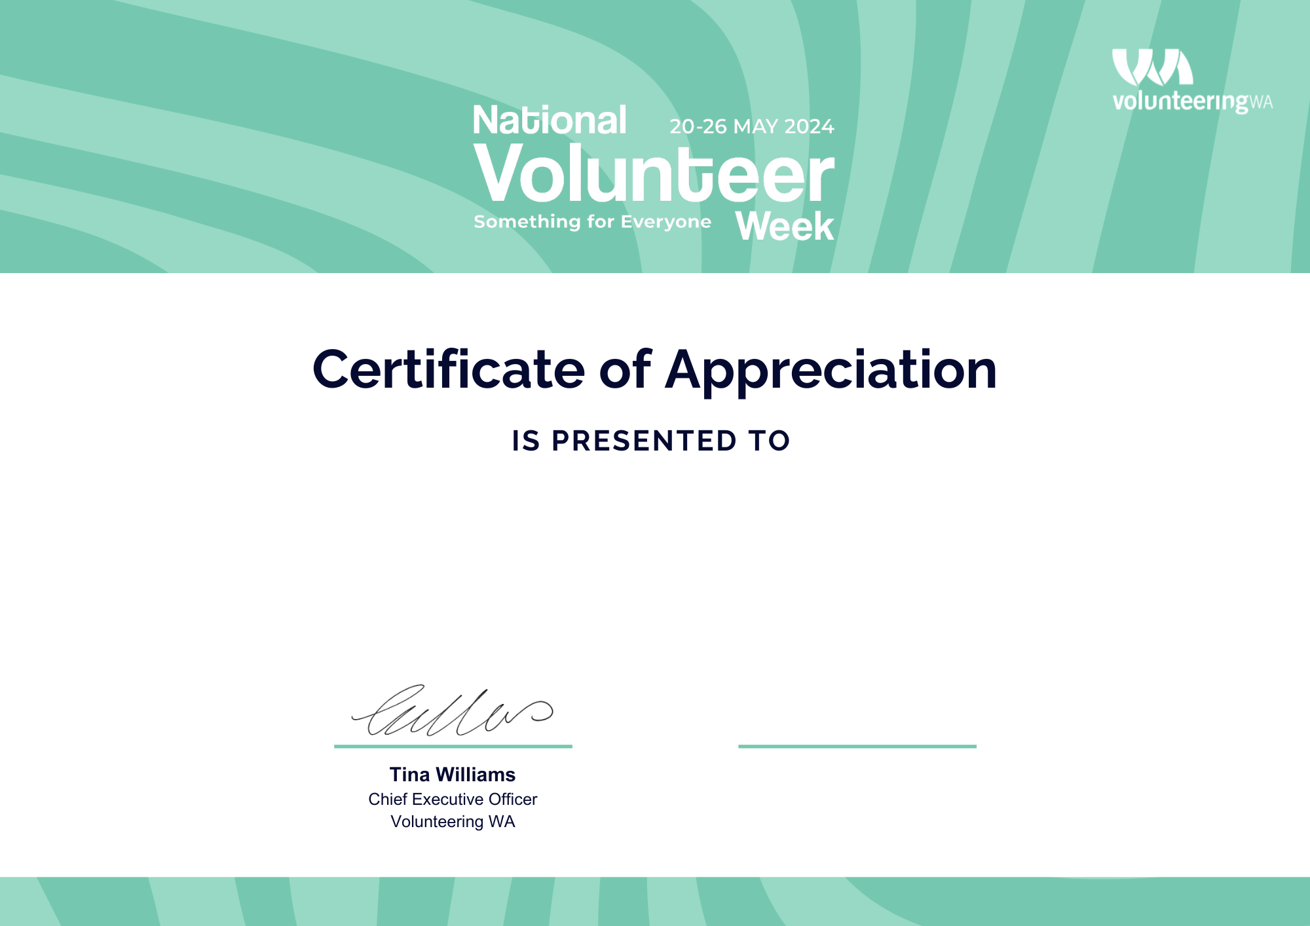

**Your CEO**

Chief Executive Officer

Your Organisation

**Thank you for dedicating your time to help the community**

**Full Name**