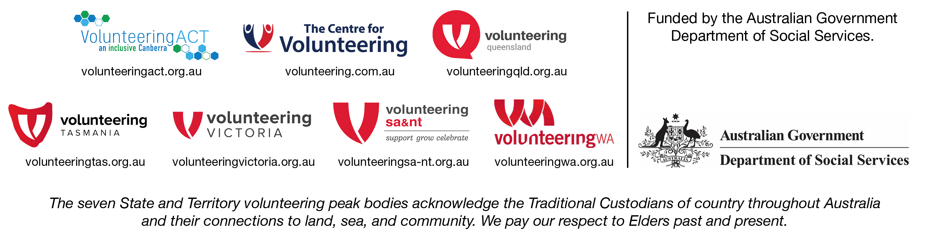
Volunteer Management Activity – Project Proposal Application
Project Title
Submitted by |  |  | Title
Organisation |  |  | ABN
Phone |  |  | Email
Address
State |  |  | P’code
Primary Contact |  |  | Phone
Position |  |  | Email
Essential eligibility requirements | To be eligible to submit a proposal for this project, the following requirements must be met.  The applicant:  - Will not be in receipt of funding for the same activity from State or Local Governments during the funding period  - Is financially viable  - Is not included in the list of organisations that have failed to join the National Redress Scheme  - Adopts child safe practices  - Has cultural competency skills  - Has no reason to believe that it is not a fit and proper entity to partner for the delivery of Australian Government funded services  - Has an Australian Business Number (ABN) or is willing to provide a Statement by Supplier Form (reason for not quoting an ABN).
 | I confirm that the organisation / entity submitting this proposal meets all the essential eligibility requirements listed above. ☐
Summary Budget  (Multiple project options are not a requirement for this submission but will be considered.) | Option A |  | Option B
Project Team | Please identify team members to be associated with this project, high level experience and anticipated availability, labour hours and responsibilities on the project – e.g. team leader; project manager; researcher; designer etc. Appendix further details as necessary.
Culture | Please detail your understanding of, and commitment to, the values of the volunteering community.
Compliance | Please document evidence of compliance with relevant regulatory requirements - such as protection of vulnerable people, OH&S, professional licensing etc.
Insurances | Please list appropriate insurances including Professional Indemnity and Public Liability coverage. Appendix Insurance Certificates.
High level services and deliverables | Outline the services, products and/or deliverables you will supply under this proposal.
Option A

Option B (if applicable)

Detailed Proposal outline | Describe in detail, how you will approach this project, including services and or products to be created. Define what is in and out of scope under this proposal. If appropriate, include multiple options and attach further details as Appendices to this proposal.
Proposal timeline | Provide a timeline detailing tasks / activities and specify milestones.
Social impact | Driving social impact is core to the Volunteer Management Activity. Please outline any contributions your organisation makes to the social objectives listed below.
Examples  - Increased purchasing from First Nations businesses.  - Improved employment prospects for the First Nations community. | Opportunities for First Nations Communities
Examples  - Increased purchasing from Australian Disability Enterprises (ADE).  - Increased employment of people living with a disability | Opportunities for people with living disability  .
Examples  - Increased compliance with the Workplace Gender Equality Act 2012.  - Demonstrated improvements to encourage gender equality in the workplace. | Opportunities for gender equality
Examples  - Increased opportunities for businesses established by community members from culturally and linguistically diverse backgrounds. | Opportunities for people from Culturally and Linguistically Diverse backgrounds
Specify any additional social impact, to which your organisation contributes. | Other social impact
Declaration of  conflict of Interest | Do you, or your organisation, have any actual or perceived conflicts of interest which may occur from submitting this Application?  ☐ Yes  ☐ No  If yes, please describe (in less than 150 words) any conflicts of interest which may occur from submitting this Application.
Risk management | Please identify and rate your risks (in accordance with the Risk matrix outlined in Appendix 1) and populate the template to identify mitigation strategies and residual risk rating.

Referees
Each referee provided must have experience working with at least one core team member.

Referee 1 (mandatory)

Core team member the referee worked / engaged with
About the work
Relevance to this application
Referee’s details
Name
Position
Organisation
Contact number
Email address

Referee 2 (mandatory)

Core team member the referee worked / engaged with
About the work
Relevance to this application
Referee’s details
Name
Position
Organisation
Contact number
Email address

Appendix 1
Risk matrix
 | CONSEQUENCE
LIKELIHOOD | Insignificant | Minor | Moderate | Major | Critical
Almost Certain | Medium | High | High | Extreme | Extreme
Likely | Low | Medium | High | High | Extreme
Possible | Low | Medium | Medium | High | High
Unlikely | Low | Low | Medium | Medium | High
Rare | Low | Low | Low | Medium | Medium
Risk Management Strategy
Consider Strategic Risks such as Legal; Financial; Human Resources; Stakeholders; Operational Service Delivery; IT/ Information Management; Reputational etc
Strategic Risk | Risk description | Initial Risk rating | Treatment plan | Residual Risk rating

Volunteer Management Activity – Project Proposal Application
Appendix Checklist

Attached Y/N | Required | Document / information / evidence
 | Y | Full Budget Breakdown
 | Y | Project Team – overview – role, experience, hours committed to this project
 | Optional | High Level Services and Deliverables (additional information/options)
 | Y | Compliance documentation
 | Y | Risk Management Strategy (Appendix 1)
 | Y | Certificates of Insurance
 | Optional | Detailed Proposal Outline (additional information)
 | Optional | Proposal Timeline (additional information)
 | Optional | Social Impact Statements (supporting documentation)
 | Optional | Other supporting documentation (please detail)

MARKET APPROACH
Expressions of interest must be received by the due date (COB AWT November 23, 2022. No late applications will be accepted. All expressions of interest to be addressed to:

VMAC Convenor, Jan Lucas – jan@volunteeringvictoria.org.au

The preferred supplier will be engaged by a formal contract.
CONTRACT MANAGEMENT/IMPLEMENTATION
A Lead Agency, Volunteering Western Australia, has been appointed to manage the relationship with the successful supplier and ensure progress and compliance against the contract. A Subcommittee will work with the successful supplier to manage project deliverables and reporting compliance.

