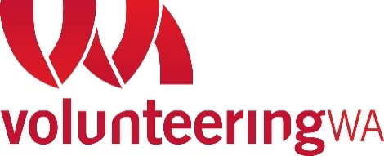

Disability Advisory Group

Who is Volunteering WA (VWA)?
Volunteering WA is the Volunteering Peak Body for volunteering in Western Australia. We aim to build strong communities through volunteering.
Background information
VWA has funding from Department of Social Services (DSS) called Volunteer Management Activity (VMA) from 2021-2026. Services provided aim to increase opportunities for people with disability to participate in the social and economic life of their broader community through volunteering.

Outcomes
- Increased opportunities for people with disability/ies to participate and reduction of barriers that prevent the inclusion of volunteers.
- High quality and accessible volunteering based on National Standards for Volunteer Involvement
- Improve the accessibility and range of quality Volunteer Management information and services across WA and Australia for people with disability/ies.

Why is the Disability Advisory Group being formed?
The aim of the group is to advise and help to understand ways in which information, services and programs in West Australia can support Volunteer Involving Organisations (VIOs) to reduce the barriers to volunteering for people with disability/ies.

VWA is seeking people and organisations to be a part of an Advisory Group who:
- Identify with or advocate for disability, including having lived experience of disability/ies.
- Can provide and share insights into the issues, barriers, and enablers for people with disability/ies participating in volunteering.
- Be available every 2 months initially from November 2021 – June 2022 with possibility of extension.

Participant requirements
Two hour face to face meetings in West Leederville, once every 2-3 months (with review and feedback of materials and/or meeting preparation).
An allowance of $180 for each meeting attendance and participation, can be offered by VWA.

How to apply:

To apply, please send us an email telling us why you would like to be involved.

Applications close: Friday 26th November 2021

Contact
If you have any questions, or require support with your application please feel free to contact:
Ms Melanie Baker
Manager VMA Program
E: melanie@volunteeringwa.org.au T: 08 9483 4333

